**Project Management**

Aim: Create a playable game with at least 5 minutes of gameplay.

Tasks to be done

The tasks that needed to be completed are as follows (in chronological order):

* Create sprites for player, platforms and background
* Creating base scene
* Creating and adding movement scripts
* Animating player
* Adding platforms to base scene
* Adding colliders to sprites
* Creating camera script
* Creating a scoring system & script
* Player kill function > including objects to kill player on collision
* Game Over scene
* Main menu scene
* Pause menu scene
* Platform generation script
* Tutorial level
* Creating music
* Implementing music
* Camera effects

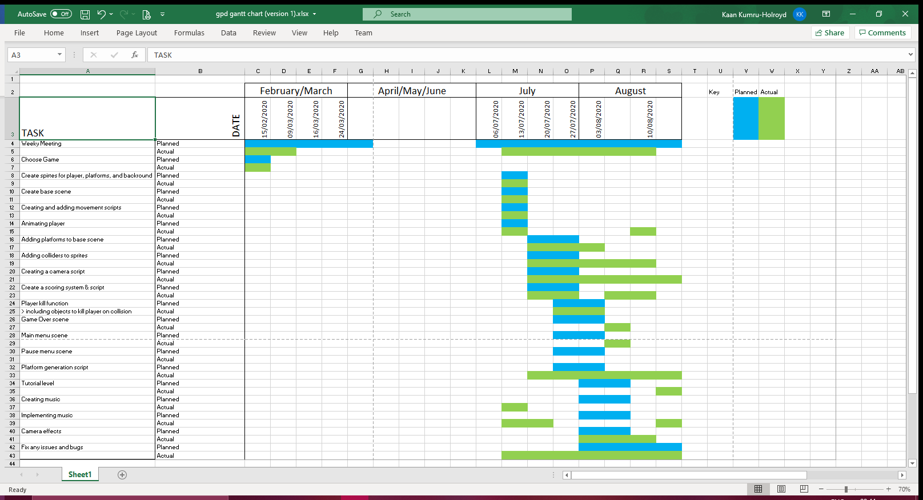Gantt chart

Group meetings

Our first group meeting was on 15/02/2020 where we initially discussed whose GDD we would be developing, it was in this discussion that as a group we concluded that Ruya’s was the best to produce and we began discussing how to go about splitting up the work. This meeting lasted an hour

Our second group meeting was on the 10/03/2020 in which we discussed what we had done so far and how to proceed, however the topics of discussion on this day became irrelevant as most of our group couldn’t work due to lack of facilities, thus resulting in us filing for a deferral so that we could have the time needed for members of our team to be able to work on the project. This meeting lasted 35 minutes

Our third group meeting was on the 15/07/2020 where our group was reduced to 3, here we discussed the immediate splitting up of work and how to proceed. This meeting lasted 20 minutes.

The fourth group meeting was on the 24/07/2020 where we discussed progress and changes that we needed to make within the game so that everything functioned properly. This meeting lasted 30 minutes.

After the 4th meeting, we worked on a chain of command in which we made implementations when called upon.

Task Allocation (Final)

* Create sprites for player, platforms, and background - Ruya
* Creating base scene - Ruya
* Creating and adding movement scripts – Ruya + Akash
* Animating player - Ruya
* Adding platforms to base scene - Ruya
* Adding colliders to sprites - Ruya + Akash
* Creating camera script - Akash
* Creating a scoring system & script Ruya + Akash
* Player kill function > including objects to kill player on collision - Ruya
* Game Over scene - Ruya
* Main menu scene - Ruya
* Pause menu scene - Ruya + Akash (pause menu scrapped)
* Platform generation script - Ruya
* Tutorial level - Ruya + Akash
* Creating music - Ruya
* Implementing music - Ruya
* Camera effects – Akash
* Fixing bugs and issues - Ruya

Software used:

* Unity 2020.1.0f
* Visual Studios
* Microsoft Excel and Word
* Beepbox.co
* Paint